|  |  |
| --- | --- |
| Primer -> Erbium  Add title **User Management** on top oft he table/filter section  4 Columns (left to right : Last name, First name, SBU – on 4th column add 2 buttons (Center & Material colors) : Edit and Icon for Off, compare <http://primer.nyasha.me/material/button> Small buttons  Ein/Aus  Edit    **General** **User Rights Assignment** **Settings**  First name Erbium Process Role Language (Pulldown reset: English)  Last name Administrator Encryption  SBU Transport Officer License  E-Mail Forklift Driver CDN  Timezone Old password   New password  Confirm new password     * Logo: change & place nicely (center) * Remove “Sign in with your app id to continue.  And Sign up for a new account. * Center Forgot password; link to <http://primer.nyasha.me/session/forgot> * Forgot password page : Use same like login, remove text « Enter your email and we'll send you instructions on how to reset your password. » and « Sign up for a new account »   **Dashboard Apps (counter: total active apps)  CTC/ADR Management  Manage entities  New Entity  Manage roles  New Role  Manage users  New User  Report Metrics Performance (counter: added since last login/cookie)  Overall Process  Transport Manager  Forklift Driver Reports Docs Support**    Manage entities / New entity  Like new user setup, but adding 2 fields in General tab:  Organisation:  Logo upload (file: .jpg, .png, .gif)  Subdomain _____.erbium.ch [-> Create the desired subdomain]  Only the Erbium Superadmin can create/manage entities  Once an entity is setup, only Administrators can create other roles/users/administrators.  Make navigation user-specific: Show only Erbium Superadmin to option to create/manage entities.  Show only Administrators the option to add/edit roles and users.  To standard users, don’t provide these add/edit options. Only show the settings. | <http://primer.nyasha.me/tables/filter>  **Not done**  <http://primer.nyasha.me/pages/user>  **Done**  <http://primer.nyasha.me/session/signin>  **Done**  **Partial done**  **Not done** |
| User Management Review:  **Neuer Transport** Transport Officer role view when login    Shipment ID  Shipment ID 1 of 10  Primary Shipment ID  Destination Dropdown countrylist  LKW Nr. text  Fahrzeughalter text  Plomben Nr. text  Container text  Fahrer text  Zuweisung Dropdown Rampe 1 to Rampe 10  Abfahrt text  Ankunft timestamp    ADR Dropdown Nein (default) ; Ja Luftfracht Dropdown Nein (default) ; Ja    Zurücksetzen Reset button  Speichern Save button    **Suche nach Shipment**  Suche button  Primary Shipment ID input search     |  |  |  |  |  |  |  | | --- | --- | --- | --- | --- | --- | --- | | **Transport ID** | **Primary SID** | **ADR** | **Luftfracht** | **Zuweisung** | **Prozess** | **Optionen** | | 16532 | 3652465389 | Nein | Nein | Rampe 3 | 1 von 5 | Bearbeiten |     6 | <http://primer.nyasha.me/material/cards>  <http://primer.nyasha.me/material/input>  <http://primer.nyasha.me/material/select>  **Not done**      <http://primer.nyasha.me/material/select>      <http://primer.nyasha.me/material/button>  New card <http://primer.nyasha.me/material/cards>  <http://primer.nyasha.me/tables/filter>  Edit button or link |

**Übersicht Transporte zur Prüfung**

|  |  |  |  |  |  |  |
| --- | --- | --- | --- | --- | --- | --- |
| **Transport ID** | **Primary SID** | **Fahrer** | **ADR** | **Luftfracht** | **Empfehlung** | **Prozess** |
| 16532 | 3652465389 | Stefan Müller | Ja | Nein | Rampe 3 | Pick & Start |
| 16533 | 365246538 | Stefan Müller | Ja | Nein | Rampe 3 | Pick & Start |
| 16534 | 3652465389 | Stefan Müller | Ja | Nein | Rampe 3 | Pick & Start |

New page

**Chemikalientransport $Primary SID von $Fahrzeughalter / $Fahrer nach $Destination**

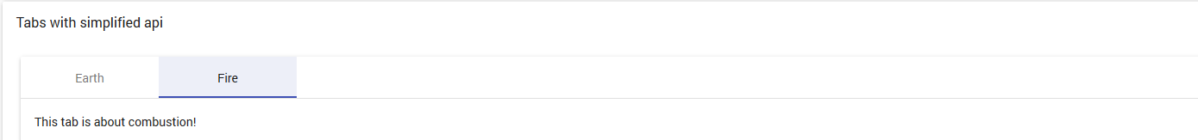 use of tabs

1. **Documents** | 2. Condition | 3. ADR | 4. Packaging | 5. Confirmation

**Not done**

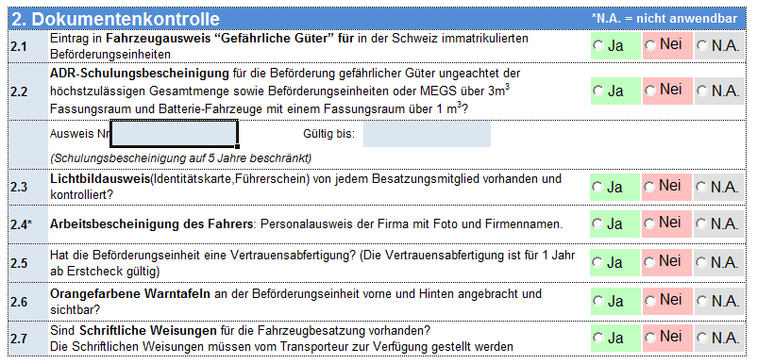 (like excel template)

Weiter

Zurück

Dashboard  
Apps (counter)  
 CTC/ADR  
Management  
 Manage entities  
 New Entity  
 Manage roles  
 New Role  
 Manage users  
 New User  
 Report Metrics  
Performance (counter)  
 Overall Process  
 Transport Manager  
 Forklift Driver  
Reports  
 Wibe Metrics  
Docs  
Support